OHM'S LAW

- Was discovered by German scientist Georg Ohm in 1826
- He discovered that if you double the voltage across a conductor, twice the current will flow through it
- So, if you triple the voltage, three times the current will flow through it.
- Because he found this out it was called OHMS LAW
- Ohms law is;

The current flowing through a conductor is proportional
to the voltage difference between its ends.
or
Provided the temperature remains constant, when a voltage is applied to a given resistance, the greater the voltage, the greater the current that flows.
Note: If the wire gets hot, the resistance changes (it increases)!

- We can show this in a mathematical formula

Or by using
Voltage
Resistance
Current
=
V
I
R
=

- V = Voltage, measured in volts (v)
- I = current, measured amps (A)
- R = Resistance, measured in ohms (Ω)

- So how can we work out current if we know the voltage and resistance
- We can use our equation triangle

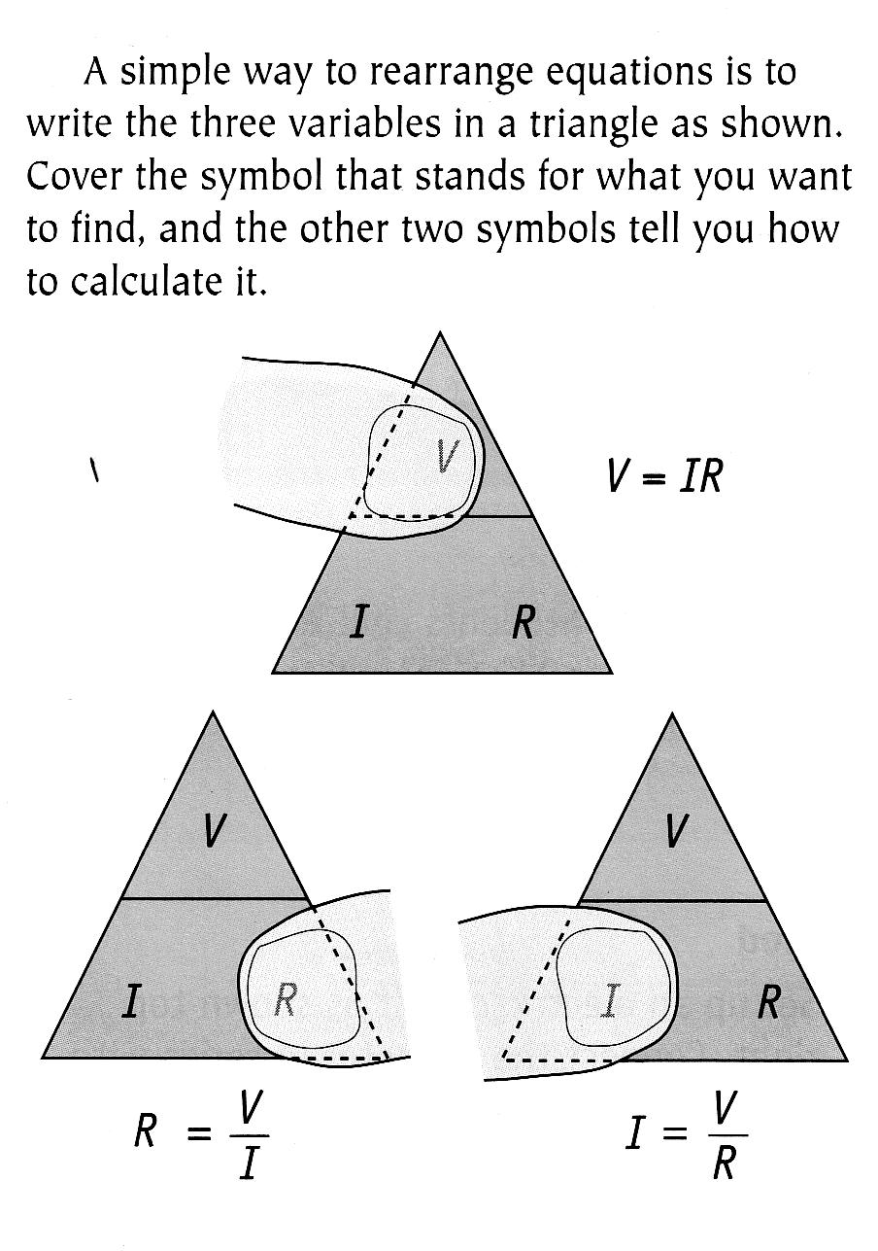
V
I
R

- Let’s try an example question…
  - If a 1.5 volt cell is connected to a lamp with a resistance of 10 ohms, what current will flow through the lamp?
What information do we have? V = 1.5 v R = 10 Ω
What do we have to find out? I = ?
What is the Ohms law equation I = V / R
Substitute or information into equation I = 1.5 / 10
Calculate the value of I I = 0.15 A
Clearly state the answer The current flowing in the lamp was
0.15 A

Your Turn

1. A current of 4.5 A flows through a resistor of 100 Ω. Calculate the voltage applied to the
resistor.
Set your working out clearly.

• Equation
• Substituted numbers
• Answer with units
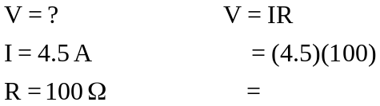
Write the data down on the left hand side including units

2. If a 1.5 V cell is connected to a globe with a resistance of 10 Ω, what current will flow
through it?

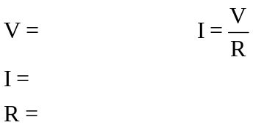

3. A room heater working on 240 V uses 5.0 A of current when it is set on its highest setting.
What is the resistance of the heater coil inside the machine?

